**PUMPS AND PROJECTS IN A FOOD GRADE OIL FACILITY**

A Research Paper

by

Luke S. Smith

Chemical Engineering Department

Junior

Second Co-op Work Term

Cargill, Inc.

Fall, 2012

presented to

Dr. Benjamin Wilhite

Texas A&M University

November 21, 2012

_____________________________

Approved by:

Patrick LaRose

Maintenance and Reliability Leader

Cargill

5000 South Blvd. Charlotte,NC 28217

704-679-7111

**Table of Contents**

***Abstract … pg. ii***

***List of Tables … pg. iii***

***List of Figures … pg. iv***

***Background … pg. 1***

***Objectives … pg. 2***

***Activities and Results … pg. 3***

**Positive displacement pumps- Scrap oil disposal … pg. 3**

**Progressive cavity pumps- Sulfuric acid addition … pg. 5**

**Centrifugal pumps- Rainwater collection … pg. 8**

***Conclusion … pg. 11***

***References … pg. 13***

**Abstract**

During my second of two consecutive co-op terms with Cargill, Inc. in the company’s Dressings, Sauces, and Oils business unit, I have continued to explore and complete capital projects throughout several departments in the plant. The majority of my projects took place in the wastewater department. During the first term I gained an understanding of the operations of the plant, and the main goal of my second term is now to put my knowledge and plans into actions and add value to the plant. The focus of my research is in regard to the different categories of pumps that I have installed or will install during my second term. Three of my projects focused on sizing and installing pumps in a variety of applications. Each application required a different type of pump, with its own theory that I learned in order to make the best decisions in each project. This paper describes the applications that lend themselves to the use of centrifugal, positive-displacement, and progressive cavity pumps, and the proper ways to go about deciding which pump is ideal for a given application, and how to size a pump to any unique system.

***List of Tables***

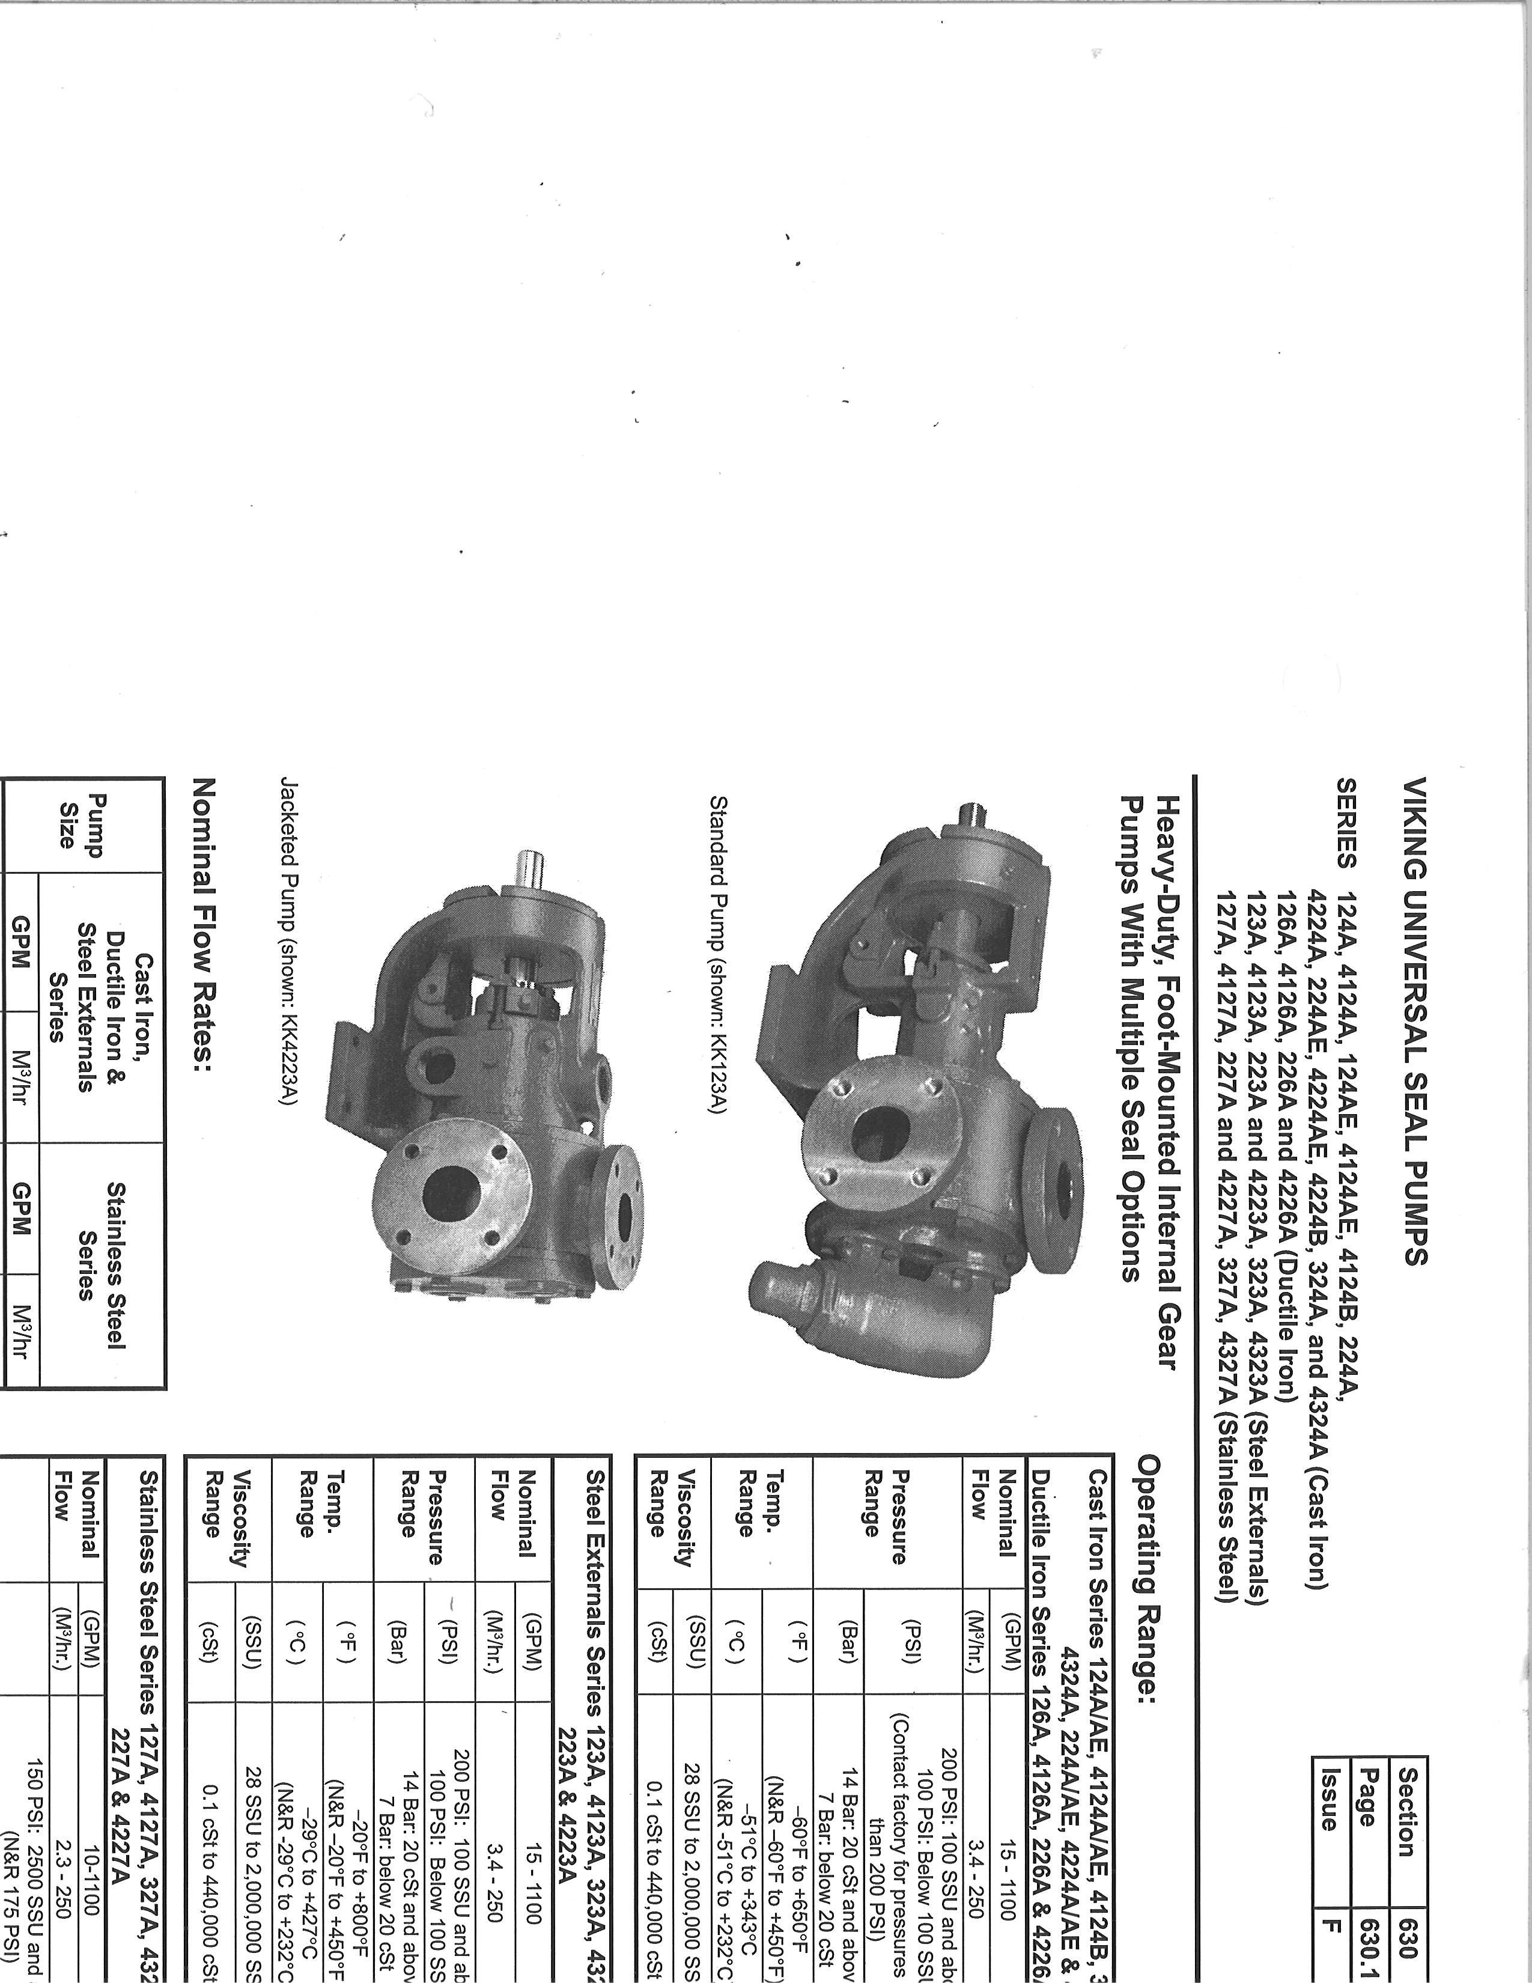

**Table 1:** P/D specs Viking handbook. All rights reserved.3

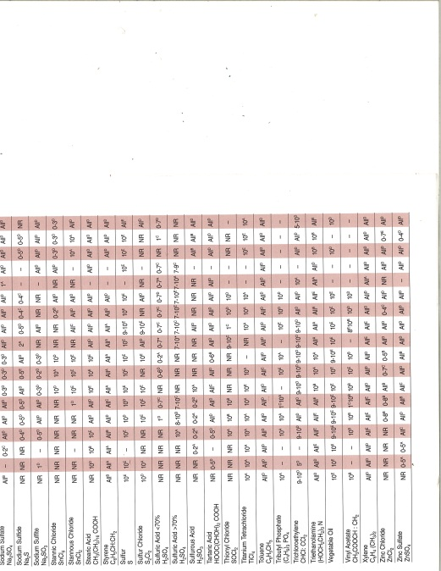

**Table 2:** An excerpt from a table describing common pump materials and their compatibility with different fluids.4

***List of Figures***



**Figure 1**: A pump curve for a Viking P/D pump. The capacity increases linearly as the gear speed increases. All rights reserved.3

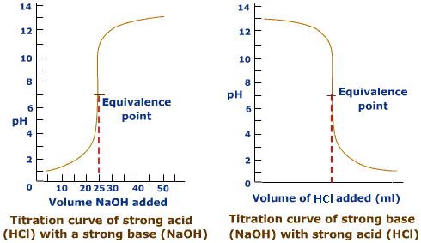

**Figure 2**: A strong-strong titration curve.6

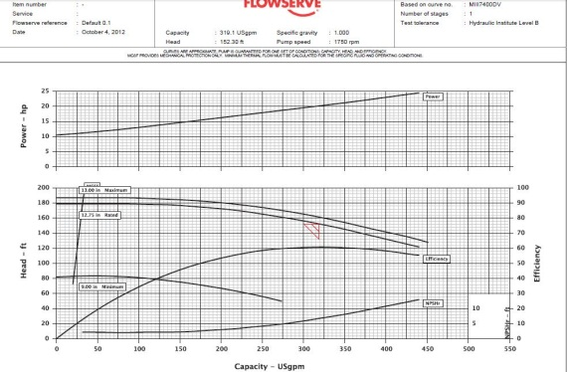

**Figure 3:** A Durco pump curve as described above, provided by Flowserve, a supplier of Durco pumps. All rights reserved.4

***Background***

Cargill, a global leader in the agriculture industry, directs nearly one hundred business units in 65 countries. These business units are organized into larger units called platforms, and one of the most prevalent platforms in North America is Cargill’s Food Ingredient Systems (FIS).1 This platform is involved with nearly every aspects of food production, from farming and risk management to the production of specialty ingredients that they sell to restaurants. The Dressings, Sauces and Oils (DSO) business unit presides over about ten facilities in North America, one of which is located in Charlotte, North Carolina.1 During my first co-op term at the Charlotte plant, I began the planning and approval process in a wide variety of capital projects. This plant produces specialty vegetable oils, and sells its products to retailers and restaurants around the country. The DSO business unit spans across North America, providing cooking oil to an expansive number of customers in various industries, from candle makers to fast food chains to big box retail stores.1

Throughout my second term with Cargill-- DSO, the pace of my work has accelerated. In my first term, I largely spent my time learning the basics of unit operations and about the products that Cargill sells. I progressed into some project work, completing the approval process in two projects and beginning that process in two other projects. In this new term, I have focused on completing the installation and implementation of the projects that were approved or were near approval at the end of the first term. Throughout the semester I have begun to explore new projects as well. Even though I will not finish all of the projects that I have started to explore in the second term, these projects will help to expand my understanding of the theory behind every project. By the end of my second term, I will have closed three projects and deployed nearly one hundred thousand dollars of capital. In addition, I will have obtained approval for six other projects that will total nearly five hundred thousand dollars in capital. These projects are diverse in nature, so I have conducted research to achieve a more specific goal: to understand the flow applications of three types of pumps, using as an example three projects that each uses a different pump for its own unique application.

***Objectives***

The three aforementioned flow application projects have increased my practical knowledge of chemical engineering during my second co-op term: two projects are ones that have continued from the first term, and one is completely new and is still in the planning and approval stages at this time. The benefit of these three projects is that each one is centered around the installation of a pump, and each project has required a different type of pump based on its application. The first project is the scrap hopper project, approved in my first term but completed in my second. This process utilizes a positive-displacement pump to pump scrap oil from barrels and totes into a storage tank. The second project’s application is to pump sulfuric acid in very small, continuous quantities to a mixing point at the inlet of a wastewater treatment tank. For this project, a progressive cavity dosing pump was installed. The third project will pump rainwater a distance of over one thousand feet from a collection tank to a treatment tank. For this application, a centrifugal pump was chosen. It is important to thoroughly understand the theories of each type of pump so that I can choose which one will be ideal for each project. Depending on the flow material, the capacity, and the ruggedness of the application, one pump will likely perform more efficiently than any other. The theory of each pump is also important to understand in order to properly size the pump. For instance, a variable frequency drive (VFD) in a centrifugal pump operates completely differently than one would in a positive-displacement pump, and the principles used to size one cannot be applied to the other. It has been beneficial for that reason that I have seen three completely unique projects with different applications in each case. The research that I have conducted demonstrates the theory that powers each type of pump with which I have dealt throughout this past term.

***Activities and Results***

**Positive displacement pumps- Scrap oil disposal**

Positive-displacement pumps are the first category of pumps of which I dealt in my project work. Positive-displacement pumps describe three prevalent types of pumps: reciprocating pumps, metering pumps, and rotary pumps.2

A reciprocating pump works by pumping a liquid from a cylinder through a suction valve and then discharging that liquid under positive pressure through the outlet valve.2 This type of pump can often be the ideal choice when the material is extremely viscous, such as crude oil or any type of slurry. However, centrifugal pumps can also be used to pump slurries, and can serve as a more cost-effective alternative to reciprocating pumps in certain applications.

A metering pump is another type of positive-displacement pump. A metering pump is used to pump very small flow rates, often less than half of a gallon per minute (GPM.)2 An example of an application that could utilize a metering pump is the sulfuric addition system, but that application will be discussed further in the section regarding progressive cavity pumps, which can serve a similar purpose as a metering pump.

The rotary pump is used extensively throughout the Charlotte facility. Rotary pumps are rugged, available in a wide variety of sizes, relatively cheap, and can accommodate a multitude of applications. Rotary pumps include many subtypes, such as internal-gear, vane, screw, and lobular.2 In the scrap hopper project, I studied and installed an internal gear pump produced by the Viking pump company.

In order to choose the most appropriate pump for my project, I had to first understand the application of the system. The material to be pumped is the most important variable to consider when a new pump needs to be chosen. In this case the material is scrap oil. Scrap oil can consist of a mixture of oils that has been spilled, sampled, or otherwise discarded throughout the plant. In practice, this oil is collected in drums or totes throughout the plant, and the drums are filled by operators whenever they discard oil. This oil is not food grade. At times, especially in the case of a large spill, dirt and rocks can mix into the scrap oil. All of this must be discarded, and all of it will need to be pumped through the scrap oil pump. A rugged pump must be chosen so that dirt and other generally inconsistent substances will not destroy the pump. There need not be a variable frequency drive on the pump, because the purpose is just to empty barrels into a tank. The rate of the emptying need to be safe, but it does not need to constantly adjust in the way that a process steam would. Therefore, an internal gear pump was determined to be the best fit for the pump.

A flow rate of 30-50 GPM was chosen as optimum for the pump so that a 55 gallon drum could be emptied in one or two minutes. The sizing of a positive-displacement pump is a quite simple task. First, a pump model must be chosen that has ranges within the target. In this case, a Viking 4124B pump came within the accepted ranges of the desired application.



**Table 1:** The operating range of a variety of Viking pumps, including the 4124B.3

It has a cast iron frame, which will perform satisfactorily with oil. If the pumping material would have been acidic, for example, a stainless steel pump or possibly even an exotic alloy pump would have been needed. Table 2 describes some examples of hazardous materials and gives the performance of a variety of handling materials.



**Table 2:** An excerpt from a table describing common pump materials and their compatibility with different fluids.4

Once the pump model has been chosen, it is now possible to size it to its specific application. The first calculations are applicable for any type of pump: this is the calculation of head. Total head for a system equals the total discharge head minus the total suction head.5 In the case of the scrap oil system, we take the bottom of the drum as the reference point on the suction side, and the top of the storage tank as the discharge reference point. The drum without a lid is an open system, and is at the same height as the pump, even though it travels up through a pipe and back down to reach the pump. It travels through two valves, one strainer, and two other flanged fittings. Using tables, the suction head is roughly negative six (-6) feet. A table in the *Cameron Hydraulic Handbook* gives accurate head values for almost every imaginable fitting.5 The system is estimated to have 120 feet of head, or nearly 50psi. The following chart demonstrates that we can achieve 50GPM with a 3 horsepower motor and a 350RPM gear speed. Since 3 horsepower motors are uncommon, I used a 5 horsepower motor. A higher horsepower motor with all other variables remaining constant will not affect flow rate, but will affect energy consumption. At this point, the pump is ordered with a gearbox with the gear reduction that will achieve that drive speed.



**Figure 1:** A pump curve for a Viking P/D pump. The capacity increases linearly as the gear speed increases.3

**Progressive cavity pumps- Sulfuric acid addition**

My project concerning progressive cavity pumps also took place in the wastewater department; however, this process treats water whereas the first project dealt with scrap oil. The water treatment system acidulates emulsified mixtures of water and free fatty acids as well as rainwater and any other water used in the plant. Sulfuric acid is added to the water coming into the wastewater facility, breaking apart the emulsions in the water and allowing the oil to separate and be skimmed. Any oil that separates from the water is skimmed off the top of the wastewater tanks and sent to the scrap oil tank (the same storage tank that was a part of the scrap oil disposal project.) Sodium hydroxide (commonly referred to as caustic) is then added to the acidic water after the oil has been skimmed and acidulated in order to neutralize the acid. The neutralized water then proceeds to an aeration tank. Aeration tanks are a common way to treat wastewater by introducing the water to an oxygenated environment filled with purifying microorganisms. The water moves into the clarifier where the microorganisms are removed from the water before the water is sent into the city within the city’s required specifications.

The sulfuric pump is an integral part of the acidulation process and the overall treatment of wastewater. On average, incoming water requires about 30 gallons per hour (GPH) of sulfuric acid in order to maintain the required pH of 2.0 in the system. The water does not come into the system with a constant pH however, so the rate of sulfuric to be added changes constantly. The system formerly used a small positive-displacement pump with a two-horsepower motor. It was equipped with a recycle valve that could monitor the flow broadly, and a variable frequency drive that could fine-tune the flow to meet specifications. The problem came about in 2010 when the plant stopped using its centrifuges. This stopped the production of the soapstock byproduct and cut the overall water usage of the plant in half. The pump that used to work effectively was now oversized. Operators continued to use the pump, but small changes to the manual recycle valve could drastically affect the flow rate. With the lesser amount of water entering the acidulation system, a dosing pump became a more appropriate choice because it could more reliably adjust its flow from 5-50 GPH without the risk of accidentally dead-heading the pump at very slow flow rates.

The sizing of a progressive cavity pump is a simple process. Again, as with the positive-displacement pump, the system head must be determined. The progressive-cavity pump uses a corkscrew shaped rotor and a long and narrow stator to push the fluid through the pump. This design offers optimal control of the flow rate because each quarter turn of the rotor will pump a specific amount of fluid from the pump. Because of their compact size and unique design, most progressive cavity pumps are sold with an accompanying motor, unlike most other types of pumps that allow a lot of flexibility in regard to the power of the motor on a given pump. All of these designs support the attempt for a progressive-cavity pump to be the best option in circumstances where precision is paramount and power needs to be limited.

A closer look at the sulfuric acid addition process sheds light on exactly why precision is so vital. A titration curve between a strong acid and a strong base (starting at high pH) shows a gradual decrease of pH when a strong acid is first introduced. This represents the system at hand when acid is added to the incoming water. The goal is to reach a pH of 2.0. A pH of 2.0 is not too difficult to achieve because it sits near the point on the graph when the decrease in pH starts to slow. However, when caustic is added to the system, it must reach a pH of 7.0. The pH of 7.0 is exactly at the steepest point in the graph, and it takes a precise amount of a strong base to achieve it. Additionally, the caustic does not aid in the breaking of the emulsions, which is the main goal of acidulation. IF the sulfuric pump fails, soaps may be formed during the caustic addition, but no real harm can be done by a slightly imprecise flow of caustic. Although it appears at first that the sodium hydroxide pump needs to be the one that should be the most precise since it is the one balancing pH at the equivalence point, in fact the sulfuric pump must be the more precise pump. Wastewater can enter the system at any pH, and the sulfuric acid must adjust in order to reach the correct pH. If the sulfuric acid pump does its job perfectly every time, the caustic pump can pump steadily without any control system at all as long as the water comes through the system at a constant rate. Even with changes in flow rate, the adjustments made by the caustic pump are easier to manage.



**Figure 2:** A strong-strong titration curve6

**Centrifugal pumps- Rainwater collection**

The key device in any centrifugal pump is the impeller. A centrifugal pump converts the electrical power from a motor into kinetic energy contained by the liquid that accelerates through the impeller and out of the pump.7 Just as with the other categories of pumps that have been discussed, there are multiple types of centrifugal pumps. The most common type is the volute pump, and the Charlotte facility uses hundreds of these pumps. Volute pumps are generally large in comparison to positive-displacement pumps or dosing pumps, and can be compatible with many different fluids depending on the material of the pump.7 Process steams of oil comprise most of the lines throughout the plant, but there are also many water lines and a few other lines containing soapstock, acid, or other less common fluids.

The application of the pump in his third project is largely interrelated to the acidulation system described in the progressive cavity pump section. Drains throughout the facility collect rainwater, and pipes carry that water to a storage tank located near the clarifier and the aerator. This water, if it passes certain chemical tests, can be sent directly to the city without any treatment. This does not require any pumping as an underground piping scheme makes it possible for gravity to push the water out the bottom of the tank and into the city’s system. However, if the water does not meet chemical requirements, it must be pumped over a thousand feet to the acidulation tanks. Currently an inconvenient situation exists where the rainwater tank shares a pump with the field pond, which also collects rainwater. The water flows through an old and failing fiberglass pipe that requires much maintenance. I have initiated a capital project to replace the fiberglass line with a stainless steel line and to add a centrifugal pump to the system that will pump exclusively from the rainwater tank and can control flow with a variable frequency drive. The stainless steel line is necessary because water can react with carbon steel piping to form carbonic acid, which quickly destroys carbon steel pipe, and fiberglass also has proven ineffective in this application. A centrifugal pump was chosen because of its capacity and its control abilities.

The sizing of a centrifugal pump is much more involved than the sizing of a positive-displacement or progressive cavity pump because of the key component in the pump: the impeller. Centrifugal force does not act linearly. In fact, centrifugal force is a physical misnomer most commonly illustrated by the classic demonstration of a bucket filled with water. If one spins a bucket full of water over his head at a high speed, the water will not fall out of the bucket at its high point. Gravity cannot overcome the centripetal force that the string exerts upon the bucket as it pulls it toward the water. The water appears to force itself upward, “centrifugally,” against the bucket. If the bucket were let go, it would project tangentially from the point of release. So also, the impeller of a centrifugal pump spins the fluid and allows it to release tangentially at the discharge end of the pump. If the speed of the impeller is halved and in fact may not pump at all if it reaches a minimum speed, the speed of the fluid is not halved, just as the bucket will not continue to hold the water if the person spins the bucket at a very slow speed. The control of a centrifugal pump is limited narrowly between two speeds in a variable frequency drive, and the flow rate cannot be adjusted as precisely, especially at flow rates. When traveling over hundreds or thousands of feet, however, the potential adjustment range is widened.

The process of sizing a pump again begins by calculating the head of a particular system. This system has 150 feet of head. That will not change regardless of the pump chosen. Refer to figure 3 for this example. The flow rate required for the system is roughly 300GPM. Two factors must be considered when choosing an impeller size: flow rate and efficiency. A larger impeller will increase the flow rate and may increase or decrease the efficiency. The graph allows the reader to compare three sizes of impellers. It is possible to interpolate the results of other impeller sizes, or to obtain curves that include other impeller sizes if necessary. If this pump was sized with a thirteen inch impeller it would pump about 375 GPM and would have an efficiency of 59%. A 12.75” impeller would have a flow rate of 320 GPM and would have an efficiency of 61%. A 9” impeller could not pump 300 GPM under any circumstances. It is likely that a 12” impeller would have a flow near 250 GPM and an efficiency of 59%, but another curve would need to demonstrate that more accurately. It appears that the 12.75” impeller is ideal for the system, so the next step is to purchase a motor. Motors run at the same speed no matter the power, but a more powerful motor will create more torque because of its increased current. Therefore, the size of a motor must not be undersized so that it will not lack the current needed to achieve the needed torque, and it should not be oversized so that it will not waste electricity. This system requires twenty horsepower (hp.) I will purchase a 25 hp motor for this system.

Other factors that must be considered and set constant before the process of sizing a pump can begin include: specific gravity, pump speed, pipe diameter (both inlet and outlet.)

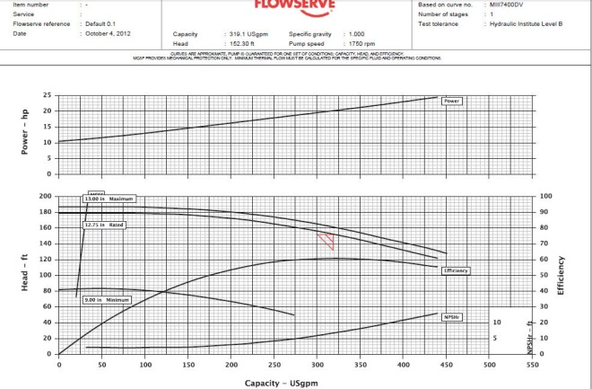

**Figure 3:** A Durco pump curve as described above, provided by Flowserve, a supplier of Durco pumps. All rights reserved.4

***Conclusions***

Throughout my second term I have made strides in my engineering capabilities, and have begun to understand the importance of having a complete and diverse understanding of the plant environment as a whole. With a less experienced perspective, it appeared to me at first that I had to only do the job of a chemical engineer to successfully implement a project. However, I have learned that it takes far more than an understanding of the major concepts of a project in order to complete that project under budget and in a timely matter. Even in those situations where the chemical concepts are prominent, such as my trim cooler installation project, it takes at least a basic understanding of the perspective of all of the departments involved. Lastly, the most important lesson that I have learned is that the most valuable way to learn something is to pursue it, explore it, and develop the answer through one’s own critical thinking. It is relatively easy to find sources that can give the correct answers, and once those sources are identified, it is easy to replace critical thinking with quick resourcefulness. An internship is an environment for critical thinking and problem solving. Secondly, it is important to understand and access one’s resources. My most noticeable growth as an aspiring professional engineer has come from a refreshed understanding of the importance of problem solving through a relentless pursuit of knowledge, and eventually answers.

***References***

1. Cargill website. No author. <http://www.cargill.com/company/glance/index.jsp>. Accessed November, 2012.

2. “Positive Displacement Pumps.” No author. www. Rpi.edu/dept/chem-eng/Biotech-environ/PUMPS/positive.html. Accessed November 2012.

3. *Viking Pump: positive displacement pumps.* A unit of IEX Corporation. Cedar Falls, IA. 2004.

4. *The Pump Company catalogue.* Flowserve Corporation. Dayton, OH. October, 1998.

5. *Cameron Hydraulic Data.* Sixteenth edition. Edited by C.R. Westaway and A.W. Loomis. Ingersoll-Rand Company. Woodcliff Lake, NJ. Published 1981.

6. “Acid-base Titration.” No author. <http://chem-guide.blogspot.com/2010/04/acid-base-titration.html>. Accessed November 2012.

7. “Centrifugal Pumps.” No author. <http://www.engineeringtoolbox.com/centrifugal-pumps-d_54.html>. Accessed November 2012.