PROCESS AND PROJECT ENGINEERING IN A FOOD-GRADE OIL REFINERY

A Research Paper
by
Luke S. Smith
Chemical Engineering Department
Junior
First Co-op Work Term
Cargill, Inc.
Summer, 2012
presented to
Dr. Benjamin Wilhite
Texas A&M University
July 30, 2012

_____________________________

Approved by:
Evan Moser
Supervisor
Cargill
5000 South Blvd. Charlotte,NC 28217
704-679-7132

Table of Contents

List of Tables … pg. iii

List of Figures … pg. iv

Background … pg. 1

Objectives … pg. 2

Activities and Results … pg. 4

Early Weeks- Skill Blocks … pg. 4

Project One- Scrap Hopper … pg. 6

Project Two- Catalyst Filter Enclosure … pg. 8

Project Three- Trim Cooler … pg. 9

Conclusion … pg. 10

References … pg. 12

List of Tables

Table 1: A portion of a specification sheet for a heat exchanger. Values are blacked out for proprietary reasons. By setting the values of certain properties, such as heat exchange rate, we can find what flow rates are required for each fluid.

Table 2: In text.

List of Figures

Figure 1: In text
Figure 2: In text
Figure 3: In text
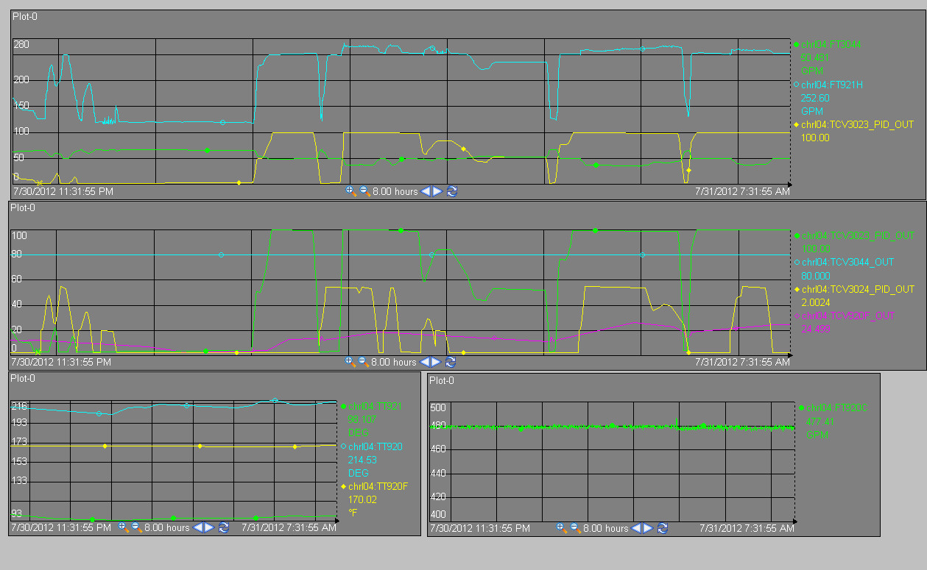
Figure 4: A series of tables from the program PI, which represents information sent by transmitters throughout the plant as line graphs over any given parameter of time. The bottom left shows the mixing of the cold stream of water with the warm stream, which runs into the trim cooler. Property of Cargill, Inc. Used with permission.

Background
Cargill, Inc. founded in 1865as a corn milling company, is the largest privately held company in the US, and operates in 65 countries as a producer and marketer of food, agricultural, financial, and industrial products and services.¹ Cargill is comprised of a variety of business units such as: corn milling, beef, salt, starches and sweeteners, and many more. Throughout both of my consecutive co-op terms I will work for Cargill’s Dressings, Sauces, and Oils division (DSO.) In this division Cargill crushes, refines, and packages many varieties of vegetable oil. Their customers include many of the largest companies in the packaged food and fast food industries. Every customer needs a different functionality for their product, and Cargill succeeds in its business by producing oil that meets each customer’s specifications.

The plant for which I will work this summer and fall is located in Charlotte, North Carolina. This plant consists of a refinery and a packaging warehouse. It does not have a crush plant attached to it, since it produces so many different varieties of oils. All of the crude oil comes into the plant by railcar where it is then purified and tweaked through three main processes. First, the oil is bleached to remove impurities. Next it is hydrogenated and/or interesterified to change its properties, namely its melting point (sometimes referred to as hardness or plasticity.) After the desired properties are achieved, the oil goes through a deodorizer, a type of distillation unit. Only after deodorization is the oil considered food grade. It can then be sent to customers in railcars or semi-trucks, or it can continue to Cargill’s packaging warehouse to be packaged into bottles, totes, or boxes. For example, many of the one-gallon vegetable oil jugs sold in supermarkets are packaged at our Charlotte DSO facility. In this co-op I will work primarily in the refinery, and most specifically in the hydrogenation unit, though my capital projects can involve all areas of the plant.

Objectives
During my first term, my primary goal is to learn everything I can about every processes and products that Cargill runs through this plant, and how these operations functions operate throughout the DSO business unit, which includes plants similar to Charlotte in five states and two countries. In order to add value to the plant, it is important to understand the business as a whole; otherwise, the strategies and improvements that I attempt to apply will fail. In the first weeks of my term, my main objective is to trace every unit and through that understand conceptually how the oil gets from one place to the next. Next, I will learn about the other utilities and chemicals used throughout each process. There are many supporting systems in addition to the oil lines themselves such as: vacuum systems, nitrogen lines, catalyst lines, steam and cooling water loops. All of these systems make the reactions possible, and each has its own system that needs to be learned and understood. After I gain a conceptual knowledge of how all these different systems interacts with each other, I must masters the controls. For the most part, electrical controls operate the system and are based upon the principles of alternating and direct current, depending on each device. The controls and transmitters give us information about the properties of the oil as it passes through the system. Since we often cannot physically see how much oil is passing through a certain pipe at a given moment, and we cannot reach out and touch it to verify that it is at the correct temperature, we rely heavily on transmitters, control valves, level pads, and many other devices to be our eyes on the inside of the system. We must have a very clear understanding of the mechanisms of these devices so we will know how much we can trust the numbers that we see on the screen. When controls fail, we need to know why it failed and how to fix it quickly so that we are not running the system blindly.

My other primary objective is to successfully design and implement numerous capital projects. By thoroughly understanding this plant and achieving my first objective, I will have prepared myself to design efficient processes that will save the plant time and money, even increase its profitability. My projects will involve contract work, so most of my time will be spent designing these projects, maintaining a budget, and finally contracting the labor to piping, electrical, and other companies. As I become more experienced with project work, my goal is to be able to finish projects faster by making better initial designs, better drawings, and clearer scope documents that will make it easier for my contractors to give prompt, accurate quotes and easier for my manager to make well-informed budget decisions without wasting any time. Overall, my goal is to finish every project that my supervisor gives me, and to work more effectively at each one than the last.

In addition to my projects, I also hope to gain experience by observing and helping the production supervisors at the plant. Most chemical or mechanical engineers that Cargill hires out of University undergraduate programs begin as production supervisors. A production supervisor at Cargill is much like a process engineer; the main difference being that every supervisor at Cargill has operators that report directly to him. In a broad sense, the supervisors, like process engineers, work as a team to improve various aspects of the plant, but on a day-to-day basis each supervisor has his own skill block that he maintains and improves upon. In Charlotte, the refinery has one supervisor in charge of the hydrogenation plant, one for the deodorizer, and one to oversee the loading and unloading of railcars and semi trucks. My objective will be to learn how each supervisor manages his operators, how they approach troubleshooting situations, and even where this job takes them in their careers so I can gain some insight into what I need to do in order to make the most out of my opportunities in my engineering career.

Activities and Results
Early Weeks- Skill Blocks
For the first two weeks of my first term at the Cargill Dressings, Sauces, and Oils plant in Charlotte, I traced each of the three main skills blocks in the refinery. The first block that I studied incorporated the hydrogenation and interesterification systems. In the hydrogenation process the oil must be fed to a heat exchanger and heated to a temperature at which it can react with hydrogen gas in order to harden to the necessary extent. Nickel acts as a catalyst in the converter.
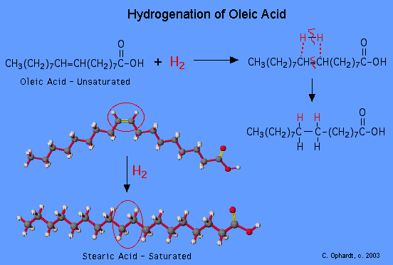
Figure 1: During the hydrogenation process, unsaturated fats are saturated.²

The oil leaves the converter at a high temperature and is cooled with a series of heat exchangers. After cooling, a filter removes the nickel from the oil. It is then bleached in a bleach tank and then sent through bag filters before being pumped out to a tank, where it will be pulled next into the deodorizer. The Charlotte plant has two independent hydrogenation systems, each one with three converters. One system is used for domestic oils, such as soy bean oil and canola oil, whereas the other system processes only oils comprised primarily of saturated lauric fatty acid strands, commonly called lauric oils. Recent demand for lauric oils have increased tremendously in the past few years and the profit margins that the Charlotte plant has enjoyed over the past decade are mainly due to the lauric oils. Coconut oil and palm kernel oil are examples of lauric oils, both having lauric strands comprise nearly half of all their fatty acid strands.³ Hydrogenation does not only saturate fatty acids strands; it can also rearrange unsaturated molecules to make trans-fats. In the figure 1, if the hydrogenation would not have been added to that oleic acid strand, the double bond could have shifted, creating trans-oleic acid, a much less marketable product because of its health concerns due to its tendency to raise LDL cholesterol.² An alternative method to hydrogenation is interesterification. Using sodium methylate as a catalyst, the general process appears similar to hydrogenation in terms of the units involved; however, interesterification can actually soften oil (i.e. decrease its melting point) by rearranging the fatty acid chains on a given triglyceride molecule, whereas hydrogenation only hardens oil by saturating the bonds on the fatty acids.

The next skill block that I studied was the refinery. About one year ago the centrifuges were taken out of service because it did not make financial sense to stop and start the system every time there was a product change, as this plant produces many different types of oils at relatively small quantities. Therefore, the Charlotte plant receives its oil by railcar, and it first passes through the bleaching system without every passing through the centrifuge. However, since the infrastructure has not been taken out yet I was able to trace the refinery and observe how the system would work if the crude oil ran through the centrifuges before it went to the bleacher.
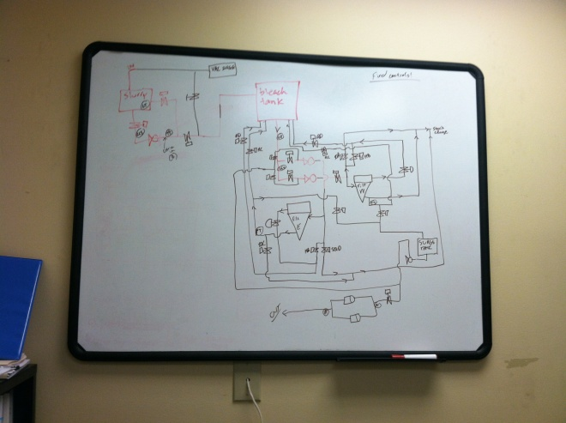
Figure 2: A tracing of the units and controls in the bleaching system.

The third skill block, the deodorizer, is the largest unit in the refinery (we use the term ‘refinery’ broadly to refer to the hydrogenation/ bleaching/ centrifugation/ deodorization blocks collectively as well as in the narrow sense referring specifically to centrifugation) and also is the last block that the oil passes through before it is packaged or sent to customers. The deodorizer consists of a series of internal units. Oil enters into the top of the deodorizers and enters a deaerating tray that consists of a series of baffles they breaks up the droplets of oil. The next tray, the heating tray increases the temperature of the oil, vaporizing any unwanted moisture or other substances and pulling those distillates into the distillate scrubber. The oil in the deodorizer moves to the pre-stripping trays, which finely sift the oil of more particulates. The oil pours into a holding tank, and then after the pre-stripping is finished, the holding tank releases the oil into another set of stripping trays, which work exactly like the first set. The cooling tray is the last tray in the deodorizer. After it has been cooled in exits the bottom of the column and is once again cooled, this time with cool water and then it exits. At this point the oil is considered edible.

Scrap Hopper
After mastering the basics of the refinery operations, I was assigned my first capital project. Throughout the refining process, samples of the oil must be taken and subjected to various chemical tests, such as atomic absorption, IV, color test, filtration, and at times others as well. Every time a sample is taken for tests, about three gallons of oil is used, and must be disposed of properly. Instead of throwing away the oil and in doing so taking a total loss of the revenue of the oil, we scrap the extra oil and sell it as a non-food grade product at a discounted rate. The scrap oil is accumulated in 55-gallon barrels which are taken daily by forklift to a scrap hopper. The oil is heated and dumped into the hopper, and then pumped into a storage tank where it can feed outgoing railcars.

The scrap hopper currently in use has broken down over time. The outlet pipe does not work and it must be pumped out with a hose. There is no automation on the pump so the steamed oil in the hopper can at times overflow onto the ground, creating a safety issue as well as wasting the time of the yard crew that then has to clean up the oil from the ground, and dump it again into the scrap hopper. Because of this I was charged with the project of building a new, safer, and more efficient scrap hopper. I worked with a piping and fabrication contractor to develop a design for the hopper itself. I write out all of the designs and modifications on isometric paper, and the contractor translated them onto autoCAD. After finalizing the design, I met with electrical, insulation, and programming contractors to receive quotes for the rest of the system. In addition, I purchased the necessary valves, transmitters, switches, and pump to supply the project.

I believe my design will solve almost all of the problems caused by the old scrap hopper. Figure 4 shows one of my isometric sketches of the hopper. It has a lip for the barrels, so that there is less of a risk of spilling it while trying to dump the oil into the hopper. The large unit next to the hopper is the oven. When we do not want to put barrels into the hopper for whatever reason, we put the barrels into an oven to heat. That way, when you do decide to dump the barrels, the oil will already be liquid and ready to pump into the tank.

Figure 3: An autoCAD representation of the scrap hopper design. Property of Industrial Piping, Inc.

The automation in the system runs to a nearby control room. The temperature transmitter, which restricts the flow of oil if the temperature is not high enough, uses an alternating current signal that can demonstrate a range of values to the program, whereas the mid-level and low-level switches use direct current signals, which can only signal on and off, in this case to start or stop the flow based on if the oil has reached those levels or not.⁴ There is a removable screen of expanded metal transverse of the hopper, in order to capture any large objects that may have gotten into the oil as a result of a spill. A threaded cam fitting is located on the output line of the hopper, allowing the option to pump directly from the hopper to a railcar, bypassing the storage tank, or allowing the option to pump from a tote filled with scrap oil directly into the storage tank, bypassing the hopper.
IPI- Piping | Materials | $xxxx.00
 | Labor | $xxxx.00
 | Demo | xxxx.55
Recore- Electrical | Materials | $xxxx.67
 | Labor | $xxxx.00
 | Demo | xxxx.44
A&E- Automation | Materials | xxxx.77
 | Labor | xxxx.00
Thermon- Heat Tracing | Materials | $xxxx.60
 | Labor | $xxxx.69
 | Indirects | $xxxx.00
 | Engineering | $xxxx.50
Carotek | Pump/Motor | $xxxx.48
 | Valves | $xxxx.00
 | Instruments | $xxxx.00
FCX | Valves | $xxxx.99
Total Capital |  | $xxxxx.94
Total Expense |  | $xxxxx.00
Subtotal |  | $xxxxx.94
Contingency 10% |  | $xxxx.79
Total Cost |  | $xxxxx.73
Table 2: The current budget for the scrap hopper project. Values have been hidden.

Catalyst Filter Enclosure
While I spend much of my workday continuing in my learning of the plant, talking with all the employees and helping out wherever I am needed, from changing filter plates in hydro to learning about every different type of pump in the maintenance shop, my weekly schedules are always anchored by my progress in my major projects. Referring again to the filters in hydro, the nickel that is deposited in these units has over time created an uncontrollable mess that permeates the entire hydro building. Because of this issue, I was charged with the project of building an enclosure around each of the two catalyst filters. After weeks of drawing and skeptical feedback about my many design ideas, I decided to perform an experiment so that I could document where specifically the nickel was spilling and how we can best design an enclosure that will keep the nickel inside the filter without becoming too restrictive and annoying for the operators who need access to the filter for daily cleanings. Visiting the maintenance shop, I found a fireproof curtain that can withstand splatter from hot slurry and some eight-foot square metal tubing. I set up the curtain on one side of the filter and as the operators power-washed the filters into the curtain I took note of the pattern of the splatter and from where the spills were coming. After this experiment I could more convincingly explain to my manager of the best way to enclose the filter. The contracting for this project was much easier, as an enclosure does not need to be automated, only fabricated. However, since the enclosure requires hot work in a building that reacts hydrogen gas, I had to schedule some down-time of the entire hydrogenation system for a few hours during the construction. As of the end of my first term, the enclosure has not been constructed, and the down-time has not been scheduled, but the capital has been approved and the contractor is awaiting the purchase order.

Trim Cooler
The project that I have most recently begun is by far my most interesting to date from a fluid dynamics and thermodynamics standpoint. Referring back to my description of hydro, this plant has two independent hydro units, one for domestics and one for laurics. The lauric system was initially built in the 1960s, and has been improved upon throughout the years. One of the oldest units in the system is the trim cooler, a tube and shell design installed in the plant in 1975. The domestic system has a trim cooler that performs the same function, but it works much more efficiently as it was installed in 2010. The domestic trim cooler uses a mixture of cooling tower water at about 90˚F and water from the plant’s heat recovery loop at about 200˚F (see figure 4 on pg iv.)

The heat recovery loop is a closed system that runs throughout the plant that absorbs and releases heat with using any external energy. For instance, it gains heat when it runs through heat exchangers against hotter oil, and loses heat when it runs through tanks containing non-flowing oil. The lauric system trim cooler runs entire on the more expensive water from the cooling tower, so we are looking into the possibility of installing a heat exchanger similar to the newer system and using heat recovery water to cool the oil coming out of the converter. Even beyond that, I have explored the possibility of switching entire to 200˚F water and not using any 90˚F water at all. That would possibly require an increased flow rate throughout the heat recovery loop (see table 1 on pg. iii.) The project will include the replacement of the heat recovery pump that runs to hydro with a pump that is currently out of service but is much stronger than the current pump. By working with the company that makes the heat exchangers, I am in the process of making the necessary energy balances to make sure that we retain our desired heat exchange rate and that we will not slow down the system. Once those calculations are complete, I will once again complete the standard capital deployment documents, safety forms, and down-time requests. I will also eventually work with a programmer to write automation to maintain the heat exchange rate throughout all the cycles of oil in the system.

Conclusions
Throughout my first term I have learned so much about engineering, and I will conclude by touching on two key lessons from this job that I will take with me immediately to my next consecutive term as well as in the future as I further my career.

First, it is important for an engineer, especially one new to a facility, to study his skill blocks and the relevant theory behind them thoroughly. On the surface, the processes and units can look very simple, and it is easy to understand them at a passable level, but when troubleshooting situations arise an engineer needs to know the system so well that he finds solutions quickly. Otherwise, those problems will cost time and money. A positive example of that came about nine weeks into my term, when the pressure on the system one converters was not decreasing as it should have been when they were venting. I followed one of the supervisors and one of the operators as they fixed the system. There was no way to see the apparent clog in the vent because the inside of the pipe is not visible. However, understanding how the demister tank traps and liquefies oil vapor if it not drained allowed them to fix the vent that afternoon without sending in a work order or slowing down their process. In addition, they noticed that the flame arrester on the line entering the demister was not serving any use, as there was very little oxygen content in the line anyway, so the hydrogen gas was not at a risk to explode. By disassembling the flame arrester from the line, they removed the obstruction that was partly at fault in causing the oil to clog the system. In this way a short term solution was reached by draining the system, and a long-term solution was discovered and can now be implemented when sufficient down-time is available on the system.

Second and possibly most importantly of all, I have learned that behaviors often differentiate an efficient process from an inefficient one. When designing a system or a piece of equipment, a good engineer must always think about how it will affect the employees who will have to operate it every day. To further that point, behaviors are difficult to change, and practicality must dictate a design and operational strategy. An obvious example of this came when I was thinking of ways to optimize our sample oil disposal system. I realized that it would be a bad idea to move the waste barrels away from the lab because the technicians do not wear helmets, gloves, glasses, or boots. Even if the yard crew could save a few minutes per day by moving the sample oil barrels to a place that they could more easily access, it would not be worth trying to change the behaviors of everyone in the lab. We should only try to change people’s behaviors if it is truly necessary, or else we will frustrate them, the plant’s overall engagement will decline, and our projects will fail.
I look forward to learning something new every day, and I always do.

References
1. Cargill website. No author. http://www.cargill.com/company/glance/index.jsp. Accessed July, 2012.

2. Ophart, Charles E. “Hydrogenation of Unsaturated Fats- Trans Fats.” Elmhurst College. c. 2003. http://www.elmhurst.edu/~chm/vchembook/558hydrogenation.html. Accessed July, 2012.

3. Gunstone, Frank D. The Lipid Library. “Oils and fats in the marketplace.” Updated February 29, 2012. http://lipidlibrary.aocs.org/market/lauric.htm. Accessed July, 2012.

4. AC/DC: What's the Difference? Edison's Miracle of Light. Published by Public Broadcasting Systems. Updated March 8, 2009. http://www.pbs.org/wgbh/amex/edison/sfeature/acdc.html. Accessed July, 2012.

